**Framing Low Risk Trade Setups**

1. What makes the setup worth taking?
   1. Selecting trade setups on higher time frame charts is ideal
   2. Large institutions and banks analyze markets on Daily Weekly and Monthly basis
   3. Locating price levels that align with institutional order flow is key
   4. Higher time frame setups form slow & provide ample time to plan accordingly
2. What can we do to lower the risk in the trade?
   1. The higher time frame has more influence on price so we focus there
   2. The conditions that lend to a trade setup on a HTF can be refined to LTF
   3. Transpose the higher time frame levels to lower time frame charts
   4. Refining HTF levels to LTF charts allows smaller stop loss placement and risk

Just because were going below old lows is not the reason we expeect a reversal, we need a HTF premise behind it

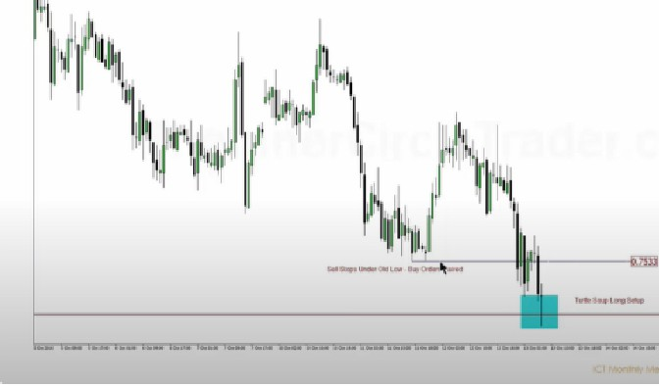

D11,-,. Bl65h Ordemlocil._

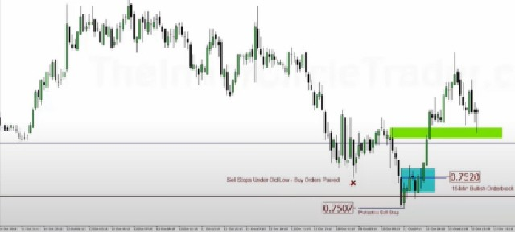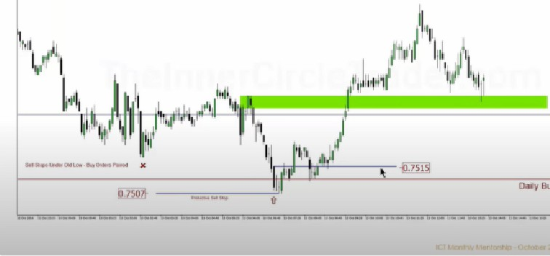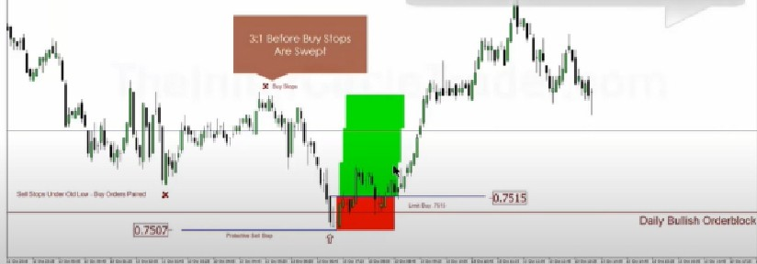

ICT lnlitrb■nk ln1dght

We we not s.r,iog to take e PIP6 111 e<:IL181profit laking - rather Mlusiratino the Reward to Rlsli. model II lhoWn In relallYe 1111115

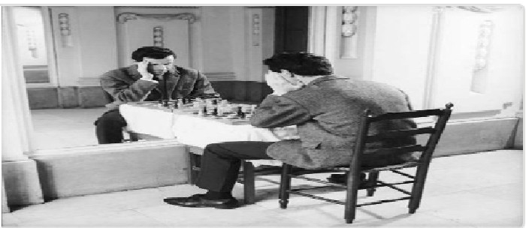Arjo I Twitter, lnstagram I Linktree

Linktree. Make your link do more.

I https://t.co/HhmmTN1fUI

JavaScript is not available.

https://twitter.com/arjoio